STUDENT NAME:

COLLEGE NUMBER:

PROFESSOR NAME:

This is an exercise based on Tableau open visualisation software. The dataset used in this application is derived from the sample sales dataset that is openly allocated and availed within Tableau software program.

The dataset is composed of 9995 instances of datasets. Upon loading the dataset in the tableau application, it looks like as below:

**Aims and objectives of the task:**

* Replicate the required assignments and tasks by changing regions from South to West regions
* Create visualisations from the West regions
* Create a story and dashboard from the provided dataset
* Be able to tell a story based on the sales regions of this dataset.

The following steps were followed:

**Step one:**

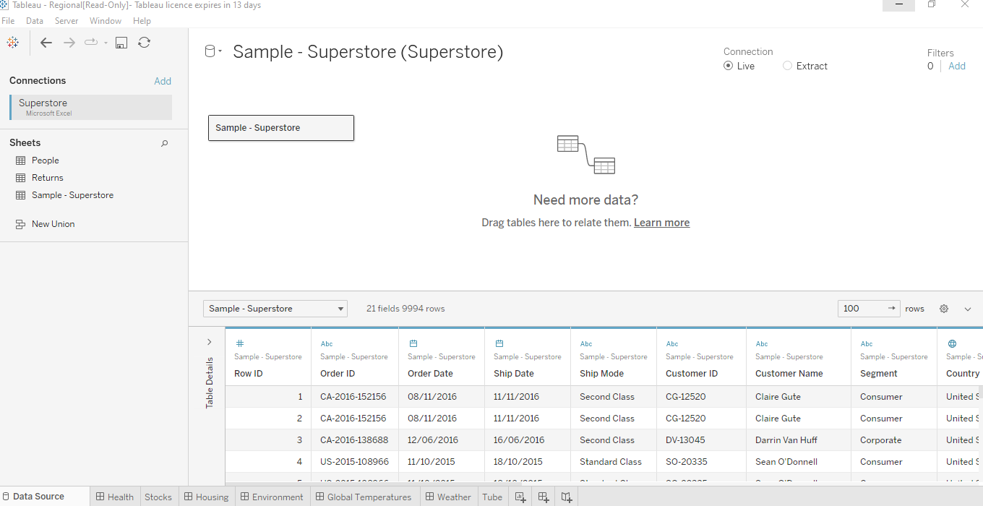

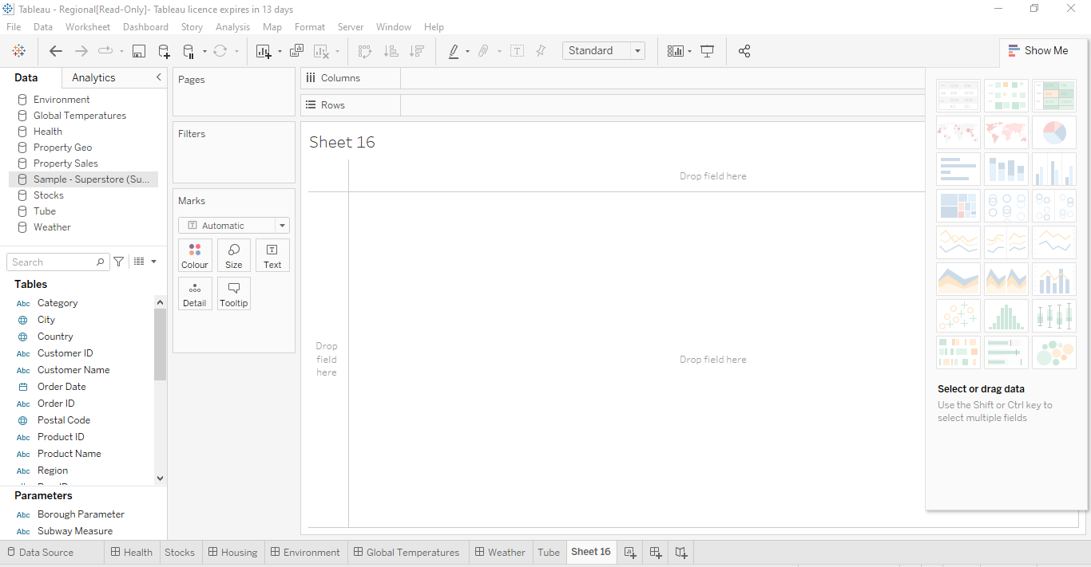

**Step two**

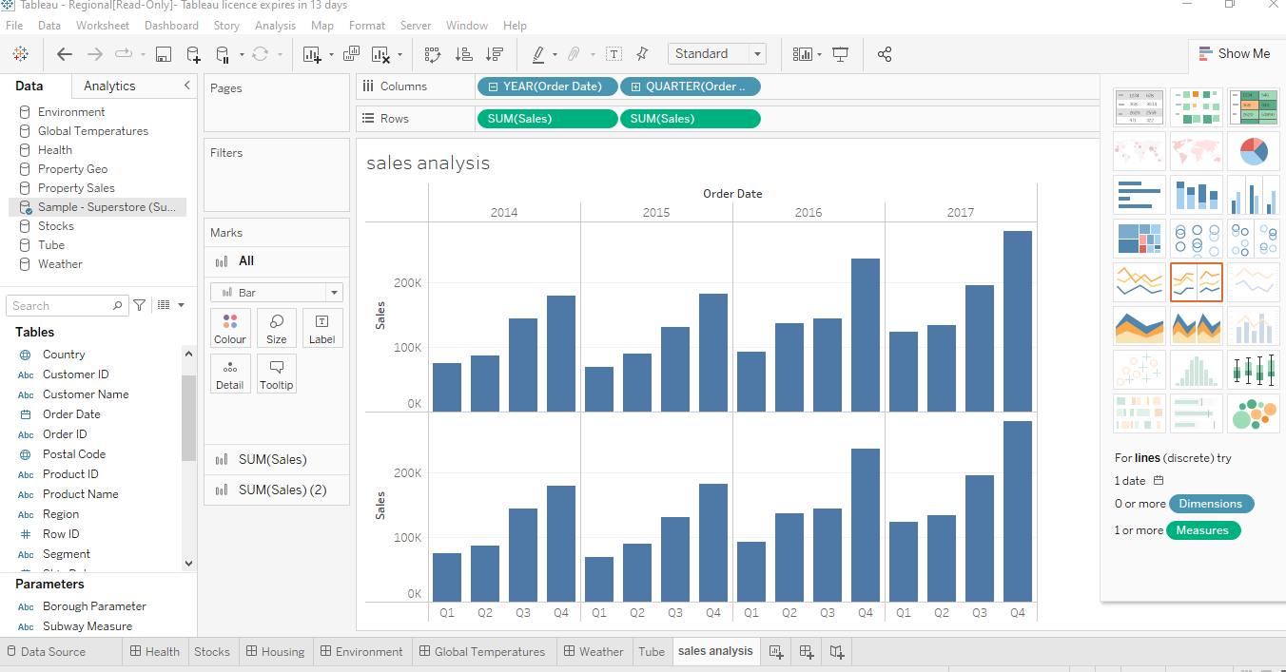

**Step three**

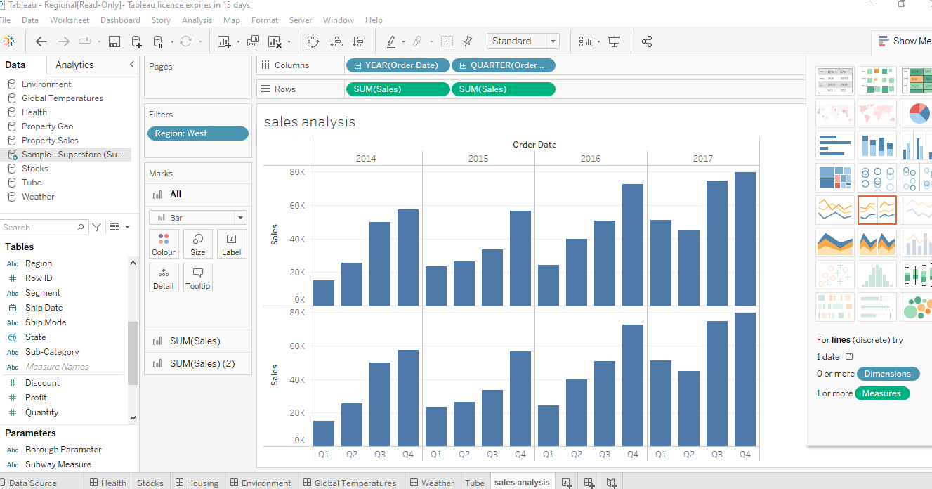

**Step four**

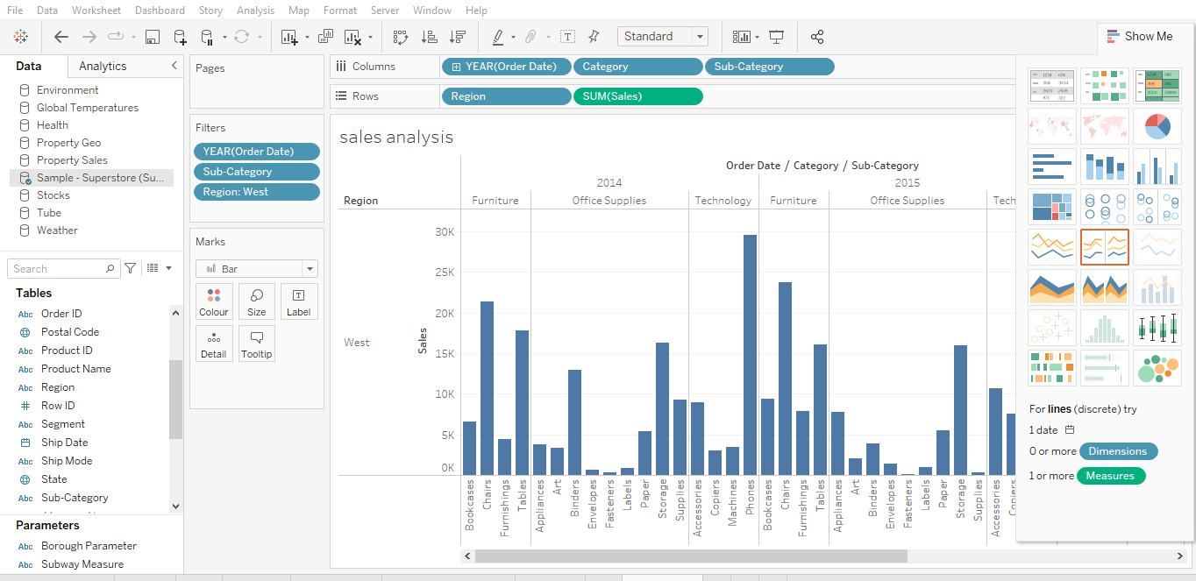

**Step five**

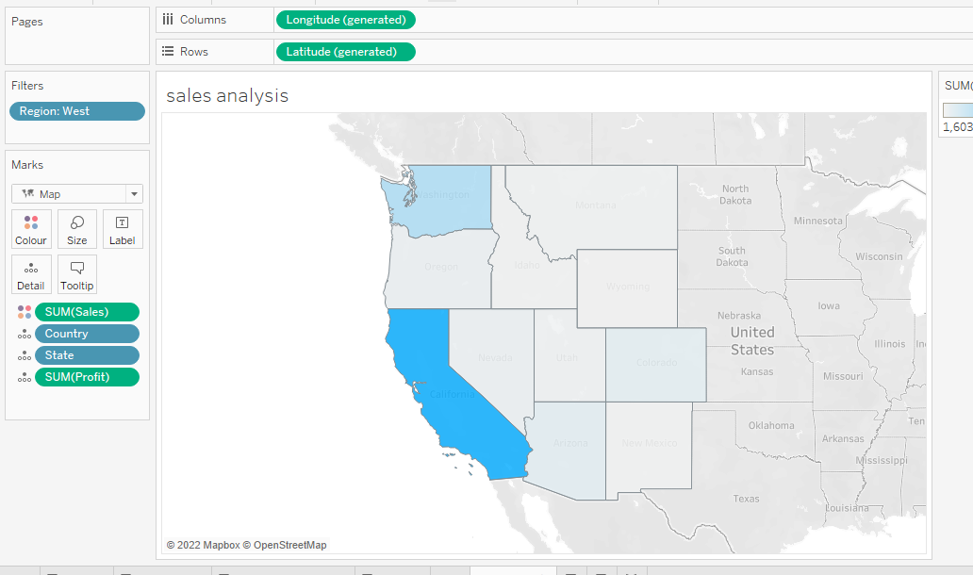

**Step six**

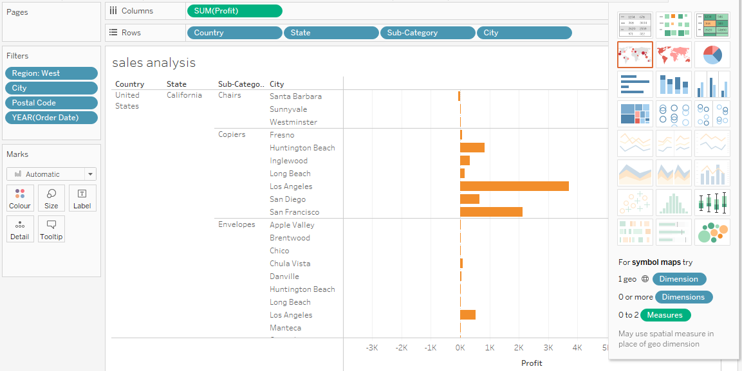

**Step seven**

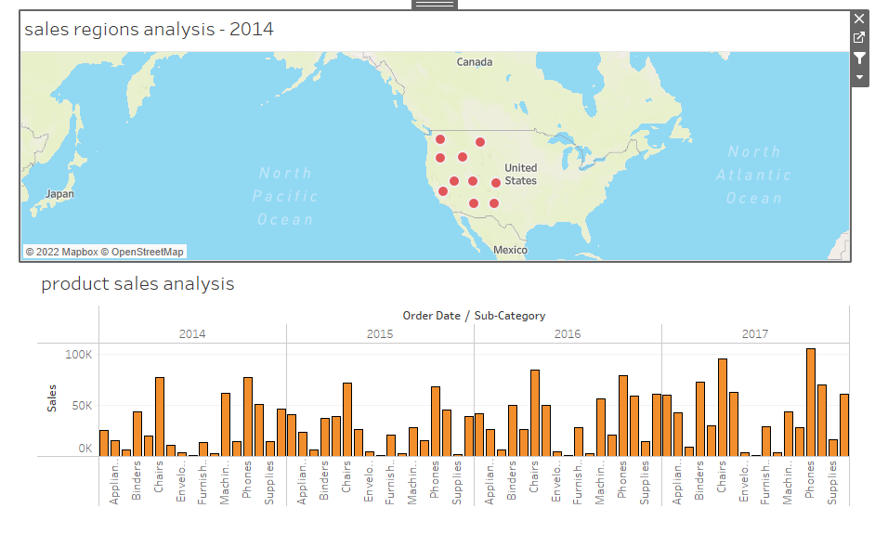

**Step eight:**

